Student Management System Documentation

Submitted By
Salman Ahmed Shah 70145697
Zohaib Nisar 70154592
Salman Manzoor 70154457

Student Management System

Introduction
Student Management System is a database project used to manage student records digitally. It helps institutes store and organize information like attendance, marks, courses, and fees.

Objectives
- Store student records digitally
- Reduce paperwork
- Manage attendance and marks
- Generate reports easily

Features

1. Student Management
- Add, update, delete students
- Search student records

2. Course Management
- Add courses
- Assign courses to students

3. Attendance Management
- Mark attendance
- View attendance reports

4. Marks Management
- Enter marks
- Calculate grades

5. Fee Management
- Manage fee records
- Check paid/unpaid fees

Software Requirements
- MySQL / SQL Server
- VS Code or Dev C++
- Windows OS

Database Design

Entities

Student
- Student_ID (PK)
- Name
- Phone
- Department

Teacher
- Teacher_ID (PK)
- Name
- Subject

Course
- Course_ID (PK)
- Course_Name

Attendance
- Attendance_ID (PK)
- Date
- Status
- Student_ID (FK)

Marks
- Marks_ID (PK)
- Total_Marks
- Grade
- Student_ID (FK)

Fee
- Fee_ID (PK)
- Amount
- Status
- Student_ID (FK)

Relationships
Entity 1 | Relationship | Entity 2
Student | Enrolls In | Course
Teacher | Teaches | Course
Student | Has | Attendance
Student | Gets | Marks
Student | Pays | Fee

ER Diagram

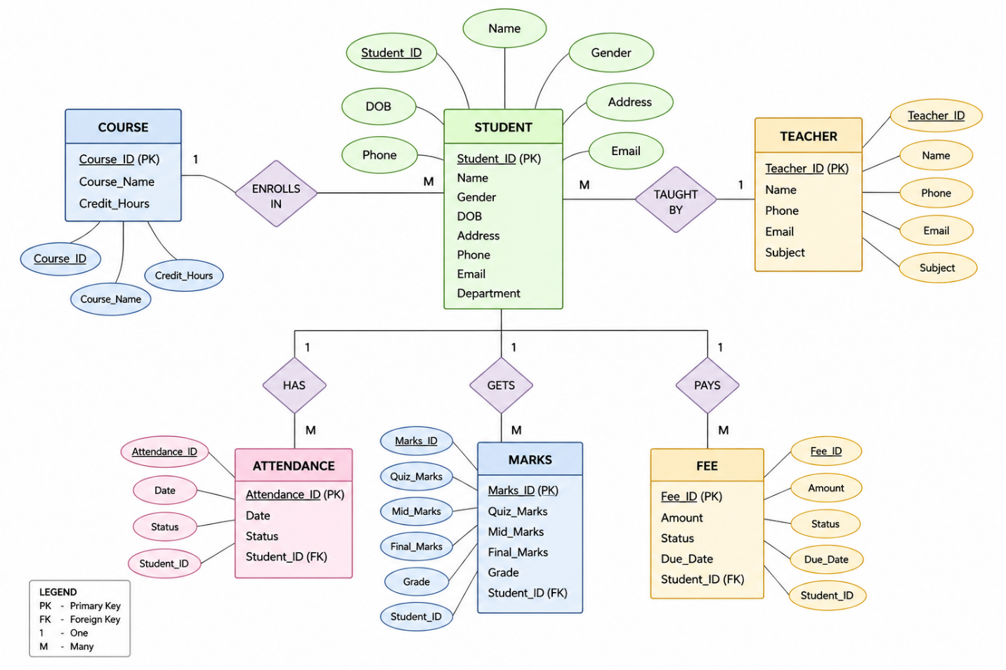

Conclusion
The Student Management System helps manage student records easily and reduces manual work. It improves accuracy and saves time for educational institutes.

